**COUNCIL REPORT**

|  |  |
| --- | --- |
| **Panel Reference** | 2019HCC016 |
| **DA Number** | DA/458/2019 |
| **LGA** | Lake Macquarie |
| **Proposed Development** | Residential Flat Building (Affordable Housing) & Commercial |
| **Street Address** | 45 Pendlebury road, Cardiff  Lot 2 DP 240602 |
| **Applicant** | Equity Development Management c/- Barr Property and Planning |
| **Owner** | 45 Pendlebury Road Pty Ltd |
| **Date of DA lodgement** | 1 April 2019 |
| **Number of Submissions** | One |
| **Recommendation** | Approval, subject to conditions of consent |
| **Regional Development Criteria (Schedule 4A of the EP&A Act)** | Private infrastructure and community facilities over $5 million - affordable housing |
| **List of all relevant s4.15(1)(a) matters** | * Lake Macquarie Local Environmental Plan 2014 * Lake Macquarie Development Control Plan 2014 * State Environmental Planning Policy (State and Regional Development) 2011 * State Environmental Planning Policy (Affordable Rental Housing) 2009 * State Environmental Planning Policy No 65 – Design Quality of Residential Apartment Development (SEPP65/3/2019 & SEPP65/3/2019/A) |
| **List all documents submitted with this report for the Panel’s consideration** | Attachment A: Draft Conditions of Consent  Attachment B: Architectural Plans  Attachment C: Landscape Plans  Attachment D: Clause 4.6 Exception to Development Standard  Attachment E: Public Submission  Attachment F: Minutes of SEPP 65 Urban Design Review Panel  Attachment G: SEPP 65 Apartment Design Guide Assessment Table |
| **Report prepared by** | Senior Development Planner – Andrew Leese |
| **Report date** | 26 August 2018 |

|  |  |
| --- | --- |
| **Summary of s4.15 matters**  Have all recommendations in relation to relevant s4.15 matters been summarised in the Executive Summary of the Council report? | **Yes** |
| **Legislative clauses requiring consent authority satisfaction**  Have relevant clauses in all applicable environmental planning instruments where the consent authority must be satisfied about a particular matter been listed, and relevant recommendations summarized, in the Executive Summary of the Council report? | **Yes** |
| **Clause 4.6 Exceptions to development standards**  If a written request for a contravention to a development standard (clause 4.6 of the LEP) has been received, has it been attached to the Council report? | **Yes** |
| **Special Infrastructure Contributions**  Does the DA require Special Infrastructure Contributions conditions (S94EF/S.7.24 )? | **N/A** |
| **Condition**  Have draft conditions been provided to the applicant for comment? | **Yes** |

**EXECUTIVE SUMMARY**

**Development Application DA/458/2019**

This report assesses the proposal against relevant State, Regional and Local Environmental Planning Instruments and Policies, in accordance with Section 4.15(1) of the Environmental Planning and Assessment Act, 1979.

|  |  |
| --- | --- |
| **Key Dates:** | Lodgement: 1 April 2019  Notification: 9 April to 30 April 2019  SEPP 65 Panel 1: 8 May 2019  SEPP 65 Panel 2: 14 August 2019  Final Plans received: 23 August 2019 |
| **Submission Period:** | 9 April 2019 to 30 April 2019 |
| **Zoning:** | B4 Mixed Use |
| **Approval Bodies:** | Subsidence Advisory NSW |
| **Referral Agencies:** | Ausgrid  Hunter Water Corporation  NSW Police |
| **CIV:** | $13,552,000 |

**Project Description**

The proposal is for a residential flat building incorporating 60 apartments with commercial unit under the provisions of State Environmental Planning Policy (Affordable Rental Housing) 2009. Compass Housing Services, who are registered under the National Community Housing Regulatory System (NCHRS) as a Tier 1 provider, will manage the development once constructed.

The revised development consists of three apartment blocks, each with four storeys, and under croft parking areas. The total number of apartments is 60 units with the following mix of one, two and three bedroom units; in each block:

* Block A contains 20 units, consisting of:
* six x one bedroom apartments,
* eight x two bedroom apartments and
* six x three bedroom apartments.

The ground floor also includes a commercial tenancy with an area of 45m2.

* Block B and Block C contain 20 apartments each consisting of:
* four x one bedroom apartments and
* 16 x two bedroom apartments.

Of the 60 apartments proposed, the six x three bedroom apartments are adaptable.

The application proposes vehicular access on the southern side of the building, a pedestrian pathway adjacent to the driveway to provide access to each apartment block and the communal open space, landscaped areas, and demolition of existing bitumen/hardstand areas.

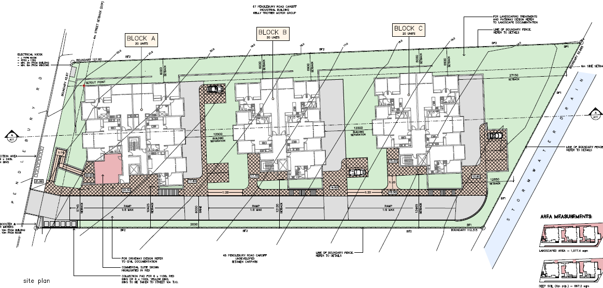

**Figure 1: Site plan of proposed development**

**Site and Locality**

The site has an area of approximately 5,200m2and is located to the south-west of the Cardiff town centre and on the north-eastern fringe of the Cardiff industrial precinct. Wests Cardiff Club is located to the south of the site and Cardiff RSL Club is located to the east of the site. The Cardiff Motor Inn is located on the opposite side of Munibung Creek.

A bus stop is located within 400m of the site on Munibung Road and the Cardiff train station is located approximately 1km to the north-east of the site.

The site has a frontage to Pendlebury Road of approximately 42m, is covered in bitumen and is currently used as a car park. The large adjoining site to the south is vacant and the adjoining site to the north contains a vehicle parts warehouse.

The site has a fall of approximately 8m from its street frontage to Munibung Creek, a formed concrete channel located at the rear of the site, owned by Hunter Water Corporation.

The site is located within a Geotechnical zone T3 and T5 under the provisions of the Lake Macquarie Local Environmental Plan 2014 (LMLEP 2014).

The site is located within a mine subsidence district. Subsidence Advisory NSW stamped plans have been provided by the applicant. The amended plans will need to be re-considered.

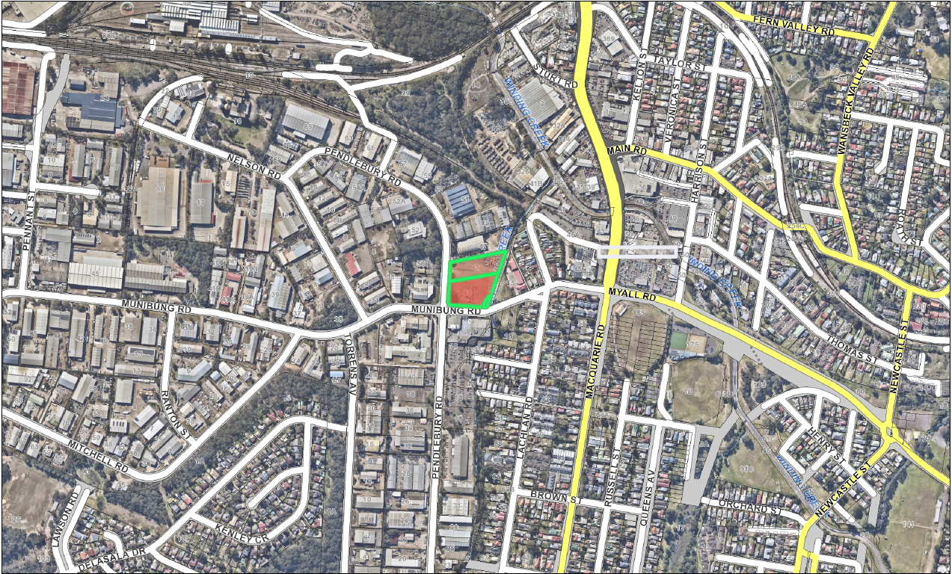

**Figure 2: Aerial map of locality (site shown in red)**

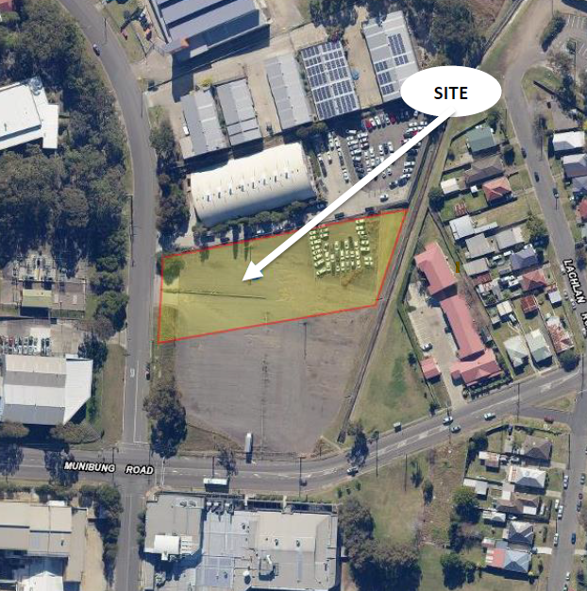

**Figure 3: Aerial photograph of the site (October 2016)**

**Background**

A pre-lodgement meeting (PL/102/2018) was held with Council in November 2018.

The development application (DA/458/2019) was lodged with Council on 1 April 2019. The application was publicly notified from 9 April to 30 April 2019. One submission was received objecting to the proposal.

The application was initially considered by the Council’s SEPP 65 Design Review Panel (DRP) on 8 May 2019.

In June 2019, the applicant was requested to address a number of issues with the development including the recommendations from the first DRP meeting.

Revised plans and documentation were submitted on 1 August 2019 in response to the issues raised. The revised plans were considered by the DRP on 14 August 2019.

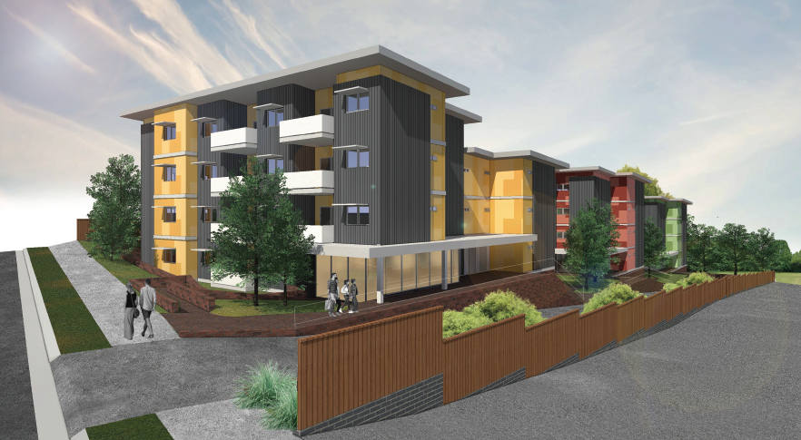

**Figure 4: Photomontage of the site looking North-East**

**The Assessment**

Under Lake Macquarie Local Environmental Plan (LMLEP) 2014, the site is zoned B4 mixed Use.As detailed in the assessment report, the development is permissible within the zone.

The proposal, whilst departing to a degree from a number of minor development controls, is assessed as being consistent with LMLEP 2014, Development Control Plan (DCP) 2014 and relevant State Environmental Planning Policies.

A comprehensive assessment of the application has been carried out under Section 4.15 of the Environmental Planning and Assessment Act 1979*,* as amended. The development is satisfactory in terms of the relevant matters for consideration under the Act and the development application is recommended for approval subject to conditions of consent.

Height/ Clause 4.6 Exemption

The development fails to comply with the statutory height control of 13m. Non-compliances are detailed visually in Figure 6.

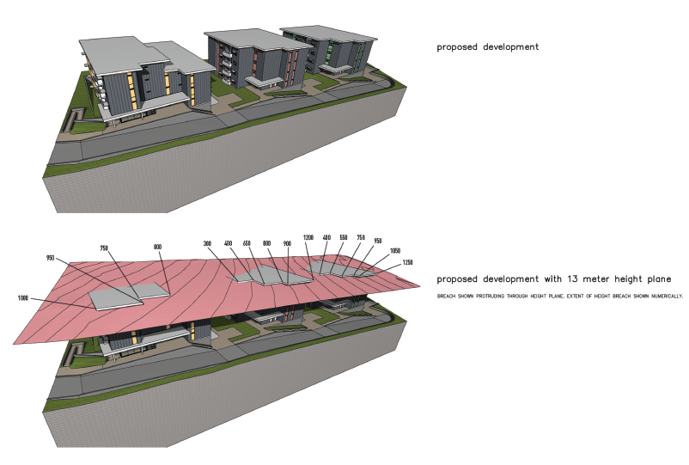

**Figure 5: Perspectives showing non-compliance with 13m height limit**

Clause 4.3 of LMLEP 2014 provides a maximum height of buildings for this site of 13m. The development proposes a maximum height of 14.25m (9.6% variation). A submission seeking a clause 4.6 variation has been submitted in support of the application. The written request is supported by Council staff.

The objectives of the standard in clause 4.3 are:

1. to ensure the height of buildings are appropriate for their location, and
2. to permit building heights that encourage high quality urban form.

(a) To ensure the height of buildings are appropriate for their location

Comment: The site and locational attributes including the surrounding 15m height limit on sites to the north and west are considered to conducive to the fourth storey of the buildings.

There are no locational impacts deriving from the proposal that would indicate inappropriateness in this context.

Compliance with the 13m height limit, as with the original design reduced setbacks and reduced the ability for good landscaping to be provided on the site.

(b) To permit building heights that encourage high quality urban design

Comment: Council’s SEPP 65 Urban Design Review Panel supports the proposal as amended. The design has an industrial character, noting that it does not sit within a standard residential area, but a mixed use zone.

The increase in height was suggested by the SEPP 65 Panel as a way to retain apartment numbers, increase amenity to the future residents, with the expectation that minor height non-compliances would have minimal environmental impacts and limited impacts on the design of the building.

The objectives of the B4 Mixed Use zone and clause 4.3 of LMLEP 2014 are met despite the non-compliance. The proposed height of the building does not result in significant environmental impact, and is consistent with the objectives of the zone and development standard.

There are sufficient environmental planning grounds to justify contravening the development standard, and compliance with the building height of 13m is in this instance unreasonable and unnecessary.

The written request has adequately addressed the above matters. The proposal will be in the public interest as it is consistent with the objectives of the height of building standard and B4 Mixed Use zone.

Council officers consider the building height variation as acceptable in this instance, as the height encroachments do not result in additional overshadowing, visual or privacy impacts, acoustic impact, streetscape impact or built form and bulk impacts.

The merits of the building height are considered to provide acceptable outcomes and the variation should be supported.

State Environmental Planning Policy (Affordable Rental Housing) 2009

This SEPP reduces a number of planning controls, such as car parking provision, on the basis that the approved accommodation is used as affordable housing, for a minimum of ten years. A detailed assessment of the application and this SEPP is found within the Assessment Report.

State Environmental Planning Policy 65 - Design Quality of Residential Apartment Development

A full copy of the final comments from the Council’s Urban Design Review Panel can be found at Attachment F. Their final conclusion is provided below:

“The panel was of the view that the revised design has addressed the major site planning issues previously identified, as well as internal amenity and security concerns. There remain a number of improvements that have been identified under the headings above, as necessary by way of design development, including landscape, aesthetics and security issues.

The panel was generally supportive of the proposal and considered that the remaining identified design refinements can be considered by Council’s assessing officers, including Council’s Landscape Architect.

The applicant has provided amended plans that:

* + increased the “visual verticality of the façade via;
  + single colour blocks on the façade modified to random pattern of two colours;
  + dark cladding modified from high solar absorbency to medium solar absorbency colour;
  + masonry retaining walls replace with non-structural retaining walls of natural materials; and
  + tree plantings on northern elevation modified to improved solar access.

**Reasons for determination**

The development has been assessed against the matters for consideration that apply to the land to which the development application relates as outlined in Section 4.15 of the Environmental Planning and Assessment Act, 1979 as follows:

* the development meets the requirements of the Lake Macquarie Local Environmental Plan 2014 and other relevant environmental planning instruments;
* consideration has been given to proposed instruments which have been the subject of public consultation;
* the development generally complies with Lake Macquarie Development Control Plan 2014 with any variations to the controls outlined and justified within this assessment report;
* considering the likely impacts of the development on the natural and built environments, the development is considered to provide balanced and appropriate outcomes;
* the suitability of the site for the development, including characteristics and constraints of the land have been considered and it was found the land as being suitable for the development;
* matters of public interest have been taken into account in relation to social, economic and environmental outcomes.

Based on the balance of the matters considered, the development application is recommended for approval. Details of the assessment are contained in the assessment report below.

**Community interest**

The assessment of the proposed development under Section 4.15(1) of the Environmental Planning and Assessment Act, 1979 has considered the community views. The development application was notified in accordance with the Development Notification Requirements outlined in Section 1.15 of Part 1 of Council’s Development Control Plan 2014 as adopted by Lake Macquarie City Council.

One submission was received in response to the public notification of the development. The matters raised in this submission were considered as part of the assessment of the proposed development. For detailed comment regarding the matters raised in the submission refer to Section 4.15(1)(d) of this report.

Community views were taken into consideration with the development being assessed against the provisions of the Lake Macquarie Local Environmental Plan 2014 and Development Control Plan 2014, both of which have been publicly exhibited and adopted by Lake Macquarie City Council.

**Recommendation**

The application is recommended for approval subject to conditions of consent.

**SECTION 4.15 PLANNING ASSESSMENT REPORT**

**Environmental Planning and Assessment Act 1979**

**Section 4.15: Potential matters for consideration**

**Section 4.15 (1)** **(a) (i) the provisions of any EPI’s**

* Applicable EPI’s, clauses or controls are detailed hereunder. Where not explicitly detailed, it is considered those EPI’s, clauses or controls are not relevant to the proposal.

**State Environmental Planning Policy (Affordable Rental Housing) 2009**

An assessment under State Environmental Planning Policy (Affordable Rental Housing) 2009 (ARH SEPP) has been undertaken. The following table provides a summary against the key development controls.

**Table 1: SEPP (Affordable Rental Housing) 2009 Key Development Standards/Controls** [That cannot be used to refuse a consent.]

|  |  |  |  |
| --- | --- | --- | --- |
| **Control** | **Affordable Rental Housing SEPP 2009** | **Proposed** | **Complies Yes / No** |
| Site requirements | Min. 450m2 | Site area is 5253m2 | Yes |
| Landscaped area | 2100m2 (35m2 per dwelling) | 25% or approximately 1300m2 | **No** |
| Deep soil planting    Deep soil in rear setback | 790m2 (15%)  525m2 (10%) | Approximately 1300m2 or 25%  530m2 or 10% | Yes  Yes |
| Solar access | Min. 70% dwellings to receive minimum 3 hours between 9am and 3pm mid-winter in living rooms and private open space. | Due to the orientation and layout of the blocks, overshadowing occurs within the site.  43 units receive complying solar access. 17 do not. This is 72% compliance.  Overshadowing of the adjacent site to the south occurs between 12pm and 3pm mid-winter, but the minimum 3hrs of sunlight is achieved between 9am and 12pm. | Yes |
| Car parking provision | 32 spaces – within a defined “accessible area”  56 spaces – in any other case  Does not strictly meet requirements for an “accessible area” due to limitations with bus service hours from 7pm up to 9pm.  Bicycle parking is shown on plans. | 33 spaces | **No, given the site is not in an “accessible area” 23 spaces short of DCP 2014 requirement.**  **However, adequate bus services are provided through daylight hours and on demand services are being rolled out across the Newcastle /Lake Mac bus network. The applicant has also agreed to provide a footpath to the bus stop.**  **No formal motorcycle parking is provided.** |
| Dwelling size | Min. 50m2 - 1 bed  Min.70m2 - 2 bed  Min. 95m2 - 3 bed | 50m2 – 1 bed  70-79m2 – 2 bed  90m2 – 3 bed | **No**  **3 bed units do not fully comply** |
| Clause 17 | Must be used for affordable housing for 10 years | Compass Housing will manage the development as affordable housing for 10 years | Yes (conditions of consent are recommended) |

The non-compliance noted above are not considered detrimental to the proposal based on location conditions and local infrastructure upgrades. A condition will require the units to be managed/leased in accordance with the SEPP.

**State Environmental Planning Policy No. 65 – Design Quality of Residential Apartment Development**

The Policy aims to improve the design quality of residential apartment development. The Policy applies to residential flat development that comprises a building of three or more storeys, and four or more dwellings.

The application proposes three x four storey buildings containing 60 dwellings in total, and therefore the policy applies.

In accordance with Division 1 of the Policy, Council has appointed a Design Review Panel (DRP) to provide expert advice regarding architectural, landscape architectural and urban design outcomes. In the assessment of a development application, Council is required to take into consideration any advice provided by the DRP.

The application was referred to the DRP in May 2019 and finally in August 2019, whereby the DRP provided comment regarding the proposed final development based upon the 9 Design Principles of the SEPP.

The Panel’s final comments are as provided in Attachment F.

In summary, the DRP supported the amended proposal noting the remaining identified design refinements can be considered by Councils assessing officers, including Council’s Landscape Architect. The matters have been addressed through assessment and the imposition of conditions of consent.

Additionally, Council has assessed the application against the Apartment Design Guide, this assessment is provided in Attachment G to this report.

**State Environmental Planning Policy (Building Sustainability Index: BASIX) 2004**

The aim of the plan is to encourage sustainable residential development, by ensuring certain forms of development incorporate suitable provision of sustainable elements. In doing so, the SEPP requires a BASIX certificate to be submitted with the application identifying a range of energy and water saving commitments that will be incorporated into the development; these commitments must be shown on the plans.

Accordingly, the applicant submitted a BASIX Certificate (Ref 1004109M, dated 27 March 2019) and plans that contain most relevant BASIX commitments. It is acknowledged the plans have not specified the central energy.

**State Environmental Planning Policy (Infrastructure) 2007**

Clause 45 requires development to consider the likely effect on electricity transmission of distribution network.

The development has been referred to Ausgrid as the existing overhead powerlines will be required to be relocated underground. Ausgrid raise no objection to the development and provided recommended conditions of consent

**State Environmental Planning Policy No 55—Remediation of Land**

The land is not identified as contaminated. A preliminary site investigation report has been lodged which concluded that no gross contaminants at locations tested. A recommendation for an unexpected finds protocol be developed for the site.

**Lake Macquarie Local Environmental Plan 2014 (LMLEP 2014)**

* Applicable clauses are detailed hereunder. Where clauses are not explicitly detailed, it is considered those clauses are not relevant to the proposal.

Clause 2.3 Zone objectives and Land Use Table

The site is zoned B4 Mixed Use.

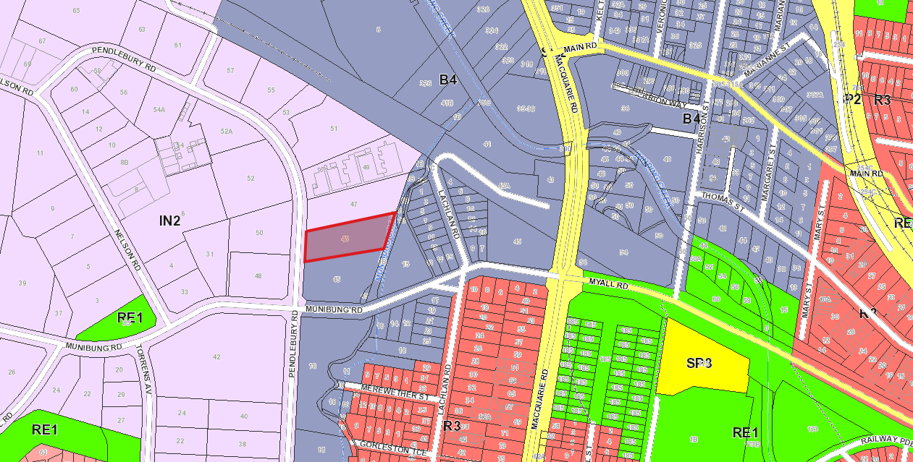

**Figure 6: Zoning Map (Extract from LMLEP 2014, site shown in red)**

The application proposes construction of a residential flat building, (with commercial component), incorporating affordable housing.

Residential flat building is defined as:

*a building containing 3 or more dwellings, but does not include an attached dwelling or multi dwelling housing.*

Residential flat buildings are permissible with consent in the B4 – Mixed Use zone. However, Clause 7.10 Residential development in certain business zones of LMLEP 2014 states:

*Development consent must not be granted to development for the purposes of a hostel, residential flat building, multi dwelling housing or serviced apartment on land in Zone B4 Mixed Use, unless it is part of a mixed use development in which all or part of the ground floor of the building facing the primary street has an active street frontage and the consent authority is satisfied that it is to be used for the purposes of commercial premises or a health services facility.*

Therefore, the development has been provided with a small commercial space is to ensure permissibility in the zone.

The objectives of the B4 zone are as follows:

* *to provide a mixture of compatible land uses.*
* *to integrate suitable business, office, residential, retail and other development in accessible locations so as to maximise public transport patronage and encourage walking and cycling.*
* *to enable development that complements and enhances the core retail function and trading performance of Zone B2 Local Centre and Zone B3 Commercial Core.*

The development (as amended) is consistent with the objectives of the B4 zone.

Clause 2.7 Demolition requires development consent

The clause requires development consent be obtained for the demolition of a building or work.

The application proposes to demolish all existing structures on the site, including hardstand areas, timber rails and fencing. Accordingly, the applicant has sought consent for these demolition works as part of the development application.

Clause 4.3 Height of buildings

The objectives of the clause are to ensure the height of buildings are appropriate for their location. Building heights should encourage high quality urban form.

The site is subject to a maximum building height of 13m.

The original application proposed a maximum building height of 12.6m complying with LMLEP 2014 height provisions.

However, the Design Review Panel has advised the site to the north (zoned IN2) has a height limit of 15m and there is an opportunity for the development to transition from this height to the 13m height control along the southern side of the site.

A clause 4.6 written variation would be required if the development is revised to exceed the 13m height limit control. The amended plans have a maximum height of 14.25m.

Clause 4.6 Exceptions to development standards

Clause 4.6 (Exceptions to development standards) of LMLEP 2014 enables variations to development standards including the heights of building.

A separate Clause 4.6 Exception to development standard has been submitted with the application for variation to Clause 4.3 of LMLEP 2014 (Height of Buildings). The application proposes a maximum building height of 14.25 metres above existing ground level. A maximum variation to the standard of 1.25 metres (9.6%) is proposed, which relates to the small sections of the roofs shown in Figure 5.

A Clause 4.6 Exception to development standard has been submitted with the application for variation to Clause 4.3 of LM LEP 2014 - Height of Buildings.

The building elements exceeding the building height are approximately 50% of the roof area, the other 50% being within the 13 metres height limit.

Development consent must not be granted for development that contravenes a development standard unless the consent authority has considered a written request from the applicant that seeks to justify the contravention of the development standard by demonstrating,

1. that compliance with the development standard is unreasonable or unnecessary in the circumstances of the case, and
2. that there are sufficient environmental planning grounds to justify contravening the development standard.

The applicant’s written variations have argued the objectives of the building height development standards are achieved notwithstanding non-compliance with the applicable standards. In particular, the written variations have argued the height of the building is appropriate for its location given permitted adjacent height controls and is appropriate in the context of the location for the following reasons:

* the height of the building is consistent with surrounding built form;
* the building has suitable separation from neighbouring sites and does not have any adverse amenity impacts in relation to solar access and visual privacy;
* the higher elements of the building that exceed the building height would not have unreasonable visual or amenity impacts;
* extensive landscaping will be planted around the building to soften and visually fragment the building;
* the building has been architecturally designed to reduce building bulk and mass.

Council consider the applicant’s clause 4.6 variations have provided sufficient argument that compliance with the development standard is unreasonable or unnecessary in the circumstances of the case, and there are sufficient environmental planning grounds to justify contravening the development standard.

In consideration of the clause 4.6 variations, Council have considered the development will be in the public interest because;

* it is consistent with the objectives of the building height standards; and
* is consistent with the objectives of the B4 Mixed Use zone.

Consideration also needs to be given to whether the variation raises any matter of significance for state or regional environmental planning, and the public benefit of maintaining the standard.

The objectives of the clause 4.3 height of buildings in LMLEP 2014 are to ensure the height of buildings is appropriate for their location, and to permit building heights that encourage high quality urban form.

For the reasons specified above by the applicant, the development is consistent with the building height standard. Particularly, the building height variation would be unperceivable in the context of the overall building form, and the variation is considered minor and not have adverse visual or amenity impacts.

With respect to the development being consistent with the objectives of the zone, the development is consistent with the B4 Mixed Use zone as it provides a building form designed to be sympathetic to the site’s topography and the surrounding mixed use/ industrial land uses.

The development provides an affordable housing units in a well-serviced location, to provide additional residential housing options for the community.

In this regard, the development is consistent with the objectives of the building height standards and zone objectives and is in the public interest.

The variation does not raise any matters of state or regional significance. Further, there is no public benefit in maintaining strict compliance with the building height standard given no unreasonable impacts result from the variation.

As the consent authority for the development application, the Hunter and Central Coast Regional Planning Panel have delegation to determine the clause 4.6 variations.

## Clause 7.1 Acid sulfate soils

Refer to assessment under DCP 2014 Part 4 Section 2.7 Acid sulfate soils.

## Clause 7.2 Earthworks

Refer to assessment under DCP 2014 Part 4 Section 2.4 Cut and fill.

Clause 7.3 Flood planning

Refer to assessment under DCP 2014 Part 4 Section 2.9 Catchment flood management.

Clause 7.10 Residential development in business zones

This clause states that development consent must not be granted to development for the purposes of a residential flat building on land in Zone B4 Mixed Use, unless it is part of a mixed use development in which all or part of the ground floor of the building facing the primary street has an active street frontage and Council is satisfied that it is to be used for the purposes of commercial premises or a health services facility.

Active street frontage is defined as street frontage that enables direct visual and physical contact between the street and the interior of the building. Clearly defined entrances, windows and shop fronts are elements of a building facade that contribute to an active street frontage.

The original application proposed a residential flat building only and was not consistent with this clause. The amended scheme now includes a small commercial space that addresses the street/main entry point to the site.

The development adequately addresses this control and the development provides an active streetscape.

Clause 7.21 Essential services

This clause states that development consent must not be granted to development unless Council is satisfied that essential services are available to the development or that adequate arrangements have been made to make them available when required.

With respect to water and sewer, the application was submitted to Hunter Water Corporation (HWC) prior to lodgement. HWC identified that water and sewer connection is available to the site (correspondence dated 10 December 2018 and plans stamped 26 March 2019). Suitable water and sewer services are available to the site.

The development proposes to build over the sewer line and therefore is required to comply with Hunter Water’s “Building Over Sewer Assets” policy. A condition of consent is recommended.

For consideration of electricity and fire safety servicing, refer to assessment under DCP 2014.

For consideration of stormwater drainage, refer to assessment under SEPP 65.

For consideration of vehicle access, refer to assessment under SEPP 65.

**Section 4.15 (1) (a) (ii) the provisions of any draft EPI**

There are no draft EPI’s applicable to the development, or site.

**Section 4.15 (1) (a) (iii) any development control plan**

**Lake Macquarie Development Control Plan 2014 (DCP 2014)**

* Applicable clauses are detailed hereunder. Where clauses are not explicitly detailed, it is considered those clauses are not relevant to the proposal.

*Part 9 – Specific Land Uses – 9.13 Residential Flat Buildings*

13.1 Site requirements

The DCP requires residential flat building development to be located on sites with sufficient size and street frontage to accommodate the required building envelope, car parking, landscaping, and private open space requirements.

The controls state a site must have a minimum area of 800m2, have direct frontage to a public road and have a minimum width of 20 metres at that road frontage.

The site has a total area of 5,253m2 and has a 42.67m frontage to Pendlebury Road. The site has sufficient area and width to accommodate a residential flat building.

13.2 Housing mix

Refer to assessment under SEPP 65 / 4K Apartment mix.

13.3 Street setback

Refer to assessment under SEPP 65 / 2B Building envelopes.

13.4 Side setback

Refer to assessment under SEPP 65 / 2F Building separation.

13.5 Site coverage

The DCP requires developments to maximise permeable surfaces and maintain a balance between built and unbuilt areas.

The controls permit a maximum site coverage at the ground floor of 65% of the site area.

The DCP defines site coverage as; the proportion of a site area covered by buildings. Site area does not include any basement, awnings adjoining the street, eaves and unenclosed balconies and the like.

Review of the plans submitted with the application identifies the proposed development has a site coverage of approximately 2,100m2. This equates to a site coverage of approximately 40%, which complies with the maximum 65%.

13.6 Landscape area

Refer to assessment under SEPP 65 / 3E Deep soil zones.

13.7 Planting on structures

Refer to assessment under SEPP 65 / 40 Landscape design.

13.8 Landscaping and tree planting in front setback areas

Refer to assessment under SEPP 65 / 40 Landscape design.

13.9 Street trees

Council’s Landscape Architect has considered the development and advised conditions of consent requiring street trees and construction of a footpath would be appropriate. A condition of consent is recommended.

13.10 Principal private open space

Refer to assessment under SEPP 65 / 4E Private open space and balconies.

13.11 Services

The DCP requires residential flat building development to provide adequate services to cater for residents’ needs.

The controls require fire hydrant services where required. Air-conditioning and other plant should also be located towards the centre of the site, and be acoustically insulated.

The SEE indicates service upgrading is required to facilitate the proposed development including a fire hydrant booster, water meters and electrical kiosk. These services should be screened from the street (if possible).

13.12 Driveways and parking areas

Refer to assessment under SEPP 65 / 3H Vehicle access and 3J Bicycle and car parking.

13.13 Adaptable Dwellings

Over half of the apartments are provided as adaptable dwellings. This complies with the requirement of one adaptable dwelling for every 10 dwellings.

Six adaptable/disable car parking spaces are provided.

13.14 Waste management

Refer to assessment under SEPP 65 / 4W Waste Management.

*Part 4 – Development in Business Zones.*

*2 Context and Setting*

2.1 Site analysis

A rsite analysis plans was lodged with the application.

2.2 Scenic values

The DCP requires development to ensure scenic values of the City are protected and enhanced.

The controls require development to be designed and sited to complement their location including; landscaping, earthworks, building design and material and colour selection.

The site is located in Scenic Management Zone 12 – hinterland, moderate settlement.

Given the location adjacent the industrial precinct and other large facilities (clubs/motel) a visual impact assessment (VIA) was not required. Perimeter landscaping will assist in ensuring the development integrates with the surrounds.

2.3 Geotechnical

The DCP requires development to minimise potential damage to buildings resulting from land movement. The site is located in a T3 and T5 zone on Council’s maps.

A Preliminary Site Investigation (Contamination) and Geotechnical Report prepared by Douglas Partners (Ref. 91022.02 and dated November 2018) has been submitted with the application.

Council’s Development Engineer has advised the Geotechnical Report needed to address slope stability. A revised report addressing slope stability was provided and concluded that geotechnical risks are very low – low.

2.4 Cut and fill

The DCP requires development to minimise the extent of earthworks (particularly outside of the building footprint), groundwater flow, stormwater infrastructure and retaining structures.

The controls require filling to not impact on the amenity of adjoining sites. Battering and retaining walls should be of appropriate heights. Retaining structures greater than 1 metre must be designed by an Engineer.

The site has a fall of approximately 8m from its street frontage to Munibung Creek, a formed concrete channel located at the rear of the site. The development includes cutting in the order of 2.5m and the majority of cut is located within the building footprint.

The proposed earthworks are consistent with DCP controls and therefore are satisfactory.

2.5 Mine subsidence

The site is located in a mine subsidence district.

Submitted plans have been stamped by Subsidence Advisory NSW dated March 2019.

2.6 Contaminated land

As noted above, a Preliminary Site Investigation (Contamination) and Geotechnical Report prepared by Douglas Partners (Ref. 91022.02 and dated November 2018) has been submitted with the development application.

Council’s Principal Environmental Officer reviewed the report and advised it is satisfactory. The report states the following:

*Based on the results of the preliminary assessment, the site is generally considered to be suitable for the proposed development from a contamination perspective, subject to appropriate inspections, assessment and management during construction under a specific unexpected fines protocol, due to the potential for variable fill materials to be present within the site.*

It is recommended conditions of consent be applied.

2.8 Stormwater management

Refer to assessment under SEPP 65 / 4V Water management and conservation.

2.9 Catchment Flood Management

The site is identified as being within a flood affected zone on Council’s maps.

The application was referred to Council’s Senior Sustainability Officer - Natural Disaster and advice provided is the development is above Council’s site-specific flood planning levels.

2.18 Social impact

A Social Impact Assessment prepared by Barr Property and Planning has been submitted with the development application.

Council’s Coordinator Community Partnerships has advised the following:

*The biggest issue associated with the proposal is with regards to the management of the property, and ensuring that the residents are supported to fully participate in the community. Whilst the Social Impact Assessment (SIA) identifies that Compass Housing will manage the property and a full range of service providers agree to provide services to the various residents of Compass developments, there is no information about this. Therefore, I request further information regarding the management of the property, to ensure that the residents will be supported to fully participate in the community.*

*Furthermore, whilst I note that some communal spaces have been provided (at the entrances to the buildings and the grassed area to the rear), I do not believe that these areas are adequate to encourage the residents to congregate and interact with each other. Encouraging interaction amongst the residents is vital to ensure that they do not become isolated, as well as assisting in building connections and a sense of community and ownership. Therefore, I request that these spaces are embellished to create these opportunities for interaction amongst the residents.*

More refined communal areas have been provided to assist in providing spaces for residents to interact and greater details of the sites future operations have been provided.

2.19 Economic impact

An Economic Impact Assessment (EIA) has been submitted.

The development will to have a positive economic benefit on the locality.

A commercial premises or medical facility will be provided on the ground floor, as noted earlier in this report. This will contribute to the economic growth of the locality as per the objectives of this section.

2.20 Lot amalgamation

The DCP aims to avoid isolated lots with limited development potential, whilst achieving efficient development on amalgamated sites.

The controls require site amalgamation to not result in isolated lots that are unviable for redevelopment for the scale and intensity desired for the locality.

An isolated lot means an allotment (or allotments) that are bounded on all sides (excluding any road frontage) by existing (or approved) medium to high-density residential or commercial development that would preclude the development of the allotment(s) beyond a dwelling house or dual occupancy dwelling or a two storey commercial or mixed use building.

The application proposes to develop a single large allotment. The lot to the south is also zoned B4 mixed use and has an area of 6273m2. This site has the potential to be developed on its own due to its large area. The lot to the north is zoned IN2 industrial general and contains an existing industrial use. The development does not create an isolated lot.

2.21 Utility infrastructure

Refer to assessment under DCP 2014 Part 9 – Specific Land Uses – 9.13 Residential Flat Buildings Section 13.11 Services.

2.22 Sites where a concept plan is required

The site has an area of greater than 4000m2 and therefore a concept plan is required to be submitted as part of a Stage 1 Development Application. The site is being fully developed at one time and therefore a concept plan is not required.

*3 Streets and Public Space*

3.4 Streetscape improvements

Refer to assessment under SEPP 65 / 3C Public domain interface.

3.5 Non-discriminatory access

Refer to assessment under SEPP 65 / 4Q Universal design.

3.6 Lighting

The DCP requires development to ensure that the impact of light and glare on surrounding residential development is minimised. Safe and convenient pedestrian movement on footpaths and through public spaces should be provided.

The applicant has not nominated the specific design and/or location of lighting. It is considered likely lighting will be used to highlight entryways and car parking areas. To ensure that lighting is installed appropriately and does not have an adverse impact to surrounding users, a suitable condition of consent is recommended.

*4 Active Street Frontage*

4.1 Ground floor residential uses in the Business Zones

Development in the B4 Mixed Use Zone is required to provide a commercial premises or health services facility on the ground floor as per Clause 7.10 of LMLEP 2014. The amended development proposes a commercial component which will comply.

*Development in the B4 Mixed Use Zone that provides commercial premises on the ground floor may satisfy the requirements of Clause 7.10 in LMLEP 2014, provided that each office and each ground floor residential unit has:*

*i. frontage to the street,*

*ii. direct entry from the street that is visible from the footpath,*

*iii. direct access to the parking area,*

*iv. a minimum floor to ceiling height of 3.0m,*

*v. a minimum area of 30m2,*

*vi. basic facilities such as a sink and toilet,*

*vii. a front terrace or deck facing the street with a maximum height above the street of 1.0m, and*

*viii. a landscape area of at least 10m2 between the street and front.*

Block A has direct entry from the street that is visible from the footpath and direct entry is provided from the car park, as per above. Internal floor heights are acceptable.

4.2 Ground floor levels

The DCP requires non-discriminatory access to be provided between the public footpath and ground floor space. Line of sight is required to be provided between the public footpath and ground floor space.

The commercial space addresses the street at the main pedestrian and vehicular entry point.

The submitted Disability Access Report states that the entry from the street to the building is accessible.

Maximum difference under the controls is 600mm between the public footpath and the internal floor level.

4.3 Ground floor entries

The DCP requires entries to be located on the street frontage and be clearly recognisable and accessible for all users.

The controls require the building entry to be located to minimise the difference between the footpath level and the internal floor level. Architectural treatment is required to distinguish entries from windows. Signage is to be integrated into façade design.

The development provides a complying ground floor entry for the residential units and provides a small commercial space.

4.4 Ground floor glazing

The development provides clear glazing to more than 50% of the façade area below the awning; however, the awning does not extend for at least 50% of the building frontage, as per Section 4.5 below.

4.5 Street awnings

The development provides an awning with depth of 2.1m but does not extend to at least 50% of the building frontage. This is a result of the awning only being over the front entry of the building and the residential nature of the development and is not opposed in this location.

Refer to assessment under SEPP 65 / 4T Awnings and signage.

*5 Access and Parking*

5.1 Traffic and vehicle access

Refer to assessment under SEPP 65 / 3H Vehicle Access and 3J Bicycle and car parking.

5.2 Design of parking and service areas

Refer to assessment under SEPP 65 / 3J Bicycle and car parking.

5.3 Bike parking and facilities

Refer to assessment under SEPP 65 / 3J Bicycle and car parking.

5.5 Car parking rates

Refer to assessment under SEPP 65 / 3J Bicycle and car parking and SEPP Affordable Rental Housing.

*6 Development Design*

6.3 Front setbacks – B4 Zone

Development complies with the minimum front setback of 4m for the B4 zone.

6.4 Façade articulation

The building includes suitable articulation along the street frontage.

Front balconies of unit 1 and unit 7 provide articulation adjacent to the front entry of the building.

6.5 Building exteriors

The building will contribute positively to the streetscape through its high quality architecture, material selection and finishes.

6.6 Building separation

Refer to assessment under SEPP 65 / 2F Building separation / 3F Visual privacy.

6.7 Side and rear setbacks

Development is required to be built to the side boundary for the ground and first level.

Driveway is provided adjacent to the southern boundary, which does not allow for the building to be built to the southern side boundary.

Nature of the location of the development does not require continuous built form along the street frontage.

The development is setback a minimum of 11m from the rear boundary and therefore easily meets the minimum setback of 1.5m from the rear boundary at ground level and 3m for upper levels.

6.8 Minimum landscaped area

Under this control, minimum landscaped area is 20% of the total site area, with at least half of this to be deep soil planting.

Refer to assessment under SEPP 65 / 3E Deep soil zones and SEPP Affordable Rental Housing.

6.9 Building depth

Building depth is 21m (24m for Block A), which exceeds the maximum 18m; however, the blocks are only two units deep and therefore units have adequate access to natural light.

Refer to assessment under SEPP 65 / 2E Building depth.

6.10 Maximum occupied area

Development complies with the maximum occupied area controls due to the large rear setback.

Refer to assessment under SEPP 65 / 2B Building envelopes.

6.12 Building height

Refer to LMLEP 2014 Clause 4.3 Height of buildings assessment.

6.14 Floor to ceiling heights

Development provides at the minimum floor to ceiling height of 3.3m for the commercial suite and ceiling height of 2.7m for dwellings.

Development complies with the minimum ceiling height of 2.7m for the upper residential floors.

Refer to assessment under SEPP 65 / 4C Ceiling heights.

6.15 Roofs

The roof form is satisfactory.

Refer to assessment under SEPP 65 / 4N Roof design.

6.16 Views

The development will not affect views due to its location adjacent to an industrial area.

6.17 Balconies and communal open space

Balconies at the first level above the street have been recessed in the street façade wall, as per the requirement.

Refer to assessment under SEPP 65 / 4E Private open space and balconies.

6.18 Planting on structures

No planting on structures is proposed as part of the development.

6.19 Solar access and orientation

Refer to assessment under SEPP 65 / 4A Solar and daylight access.

6.20 Energy efficiency and generation

Refer to assessment under SEPP (BASIX).

No air conditioning is proposed.

6.21 Visual privacy

Refer to assessment under SEPP 65 / SEPP 65 / 2F Building separation / 3F Visual privacy.

6.22 Acoustic privacy

Refer to assessment under SEPP 65 / 4H Acoustic privacy.

6.23 Front fences

No front fencing is proposed, which is satisfactory.

6.24 Side and rear fences

The DCP requires development to provide privacy and security for residences. Visual impact of fencing should be limited.

The controls require fencing to not exceed 1.8 metres above existing ground level, inclusive of any retaining walls.

Design Review Panel recommended fencing along the rear boundary for security purposes due to the site abutting a Hunter Water drainage channel.

No details of side or rear fencing is shown on the plans. Montages show standard type fencing; this is not opposed.

6.25 Safety and security

The DCP requires development to ensure that development mitigates opportunities for crime, and perceived opportunities for crime.

The controls require development to be designed in accordance with Crime Prevention Through Environmental Design (CPTED) principles.

A Crime Risk Assessment Report prepared by CHD Partners (March 2019) has been submitted with the application.

For consideration of this matter, the application was referred to Council’s Youth and Safety Officer. The officer was supportive of the development and recommended outcomes.

The Crime Risk Assessment Report will from part of the approved documentation and a condition for the removal of graffiti will be applied to any consent issued.

The Officer has recommended mail boxes be provided in the lobby. This will be made a condition of consent.

*7 Landscape*

7.1 Landscape design

Council’s Landscape Architect has advised the landscaping meets DCP 2014 requirements, with the landscaped area being generally contiguous and providing visual separation between the buildings.

The officer has advised landscape width should be increased along the northern boundary to provide visual softening of the northern industrial use. This has been provided.

The landscape design is supported.

7.2 Street trees and streetscape improvements

Council’s Landscape Architect has advised three street trees should be provided.

Provision of three street trees is a recommended condition of consent.

7.3 Landscape and tree planting in front setback areas

Refer to assessment under SEPP 65 / 4O Landscape design.

*8 Operational requirements*

8.1 Demolition and construction waste management

The DCP requires development to appropriately manage demolition and construction wastes.

Building wastes will be generated from the development. A waste management plan has been submitted.

To ensure that any wastes are appropriately managed, a suitable condition of consent is recommended.

8.2 Waste management

The SEE states the development will be serviced by the local council weekly rubbish collection. The bin storage area for each block of units is contained in their respective car parking areas.

Each block is provided with a waste area that is accessible. Communal collection and movement of waste to the main collection point will be managed on-site.

Refer to assessment under SEPP 65 / 4W Waste Management.

8.5 Erosion and sediment control

The DCP requires development to prevent erosion and sediment laded run–off during site preparation, construction and the ongoing use of land.

The application will incorporate earthworks and the potential for erosion and sediment run-off exists. Accordingly, the applicant has submitted a Soil and Water Management Plan (SWMP) prepared by Michael Fitzgerald Consulting Engineers Pty Ltd.

8.7 Noise and vibration

The DCP requires development to minimise generation of noise and/or vibration impacts.

The controls require noise generated by the development to comply with relevant environmental noise standards.

To ensure that the construction of the development occurs within relevant environmental standards, a suitable condition of consent will be imposed.

For consideration of ongoing noise, refer to assessment under SEPP 65 / 4H Acoustic privacy.

**Section 4.15 (1) (a) (iv) any matters prescribed by the regulations**

The Regulations contain provisions where demolition works are proposed. The application will undertake demolition works, (rather minor removal of hard surfacing).

To ensure that demolition works are undertaken in accordance with relevant standards, a suitable condition of consent will be imposed.

**Section 4.15 (1) (b) the likely impacts of the development**

The likely impacts of the development contained in this part of the Act have been detailed throughout the assessment report.

**Section 4.15C (1) (c) the suitability of the site for development**

**Does the proposal fit the locality?**

The site is at the border of two zones and the locality is already quite mixed in terms of land uses. It is considered the proposed development fits the locality; a sufficient buffer to the existing industrial development is provided and the site is well located in relation to services.

**Are the site attributes conducive to development?**

As demonstrated in this report, the site is conducive to the development proposed.

**Section 4.15 (1) (d) any submissions made in accordance with this Act or the Regulations?**

Public submissions

The application was notified to adjoining and adjacent allotments from 9 April until 30 April 2019. One submission was received.

The main issues raised in the submission are addressed below:

*Three storey development not consistent with locality or objectives of the B4 zone*

There are other developments in locality including to the south of the site - Cardiff Panthers (Wests) Club on Munibung Road. Surrounding sites have a 15m height limit and the variation to the 13m height limit proposed by the development is considered minor.

*Isolated residential development*

Site is zoned B4 Mixed Use which permits residential development in conjunction with a commercial premises or health services facility. The development proposes a commercial component to the building. Residential areas exist to the east and south east of the site. Other largescale residential development (with commercial component) has been approved, (and is under construction in Sturt Road), in the Cardiff B4 mixed use zone.

Council’s Coordinator Community Partnerships has advised the site is well serviced and is suitable to accommodate affordable housing.

*Lack of car parking and potential impact on road network/ Not adequately served by public transport*

Development provides for 33 car parking spaces. This is satisfactory/complying where the development satisfies the following accessible area definition from *SEPP Affordable Rental Housing:*

1. 800 metres walking distance of a public entrance to a railway station or a wharf from which a Sydney Ferries ferry service operates, or
2. 400 metres walking distance of a public entrance to a light rail station or, in the case of a light rail station with no entrance, 400 metres walking distance of a platform of the light rail station, or
3. 400 metres walking distance of a bus stop used by a regular bus service (within the meaning of the [Passenger Transport Act 1990](https://www.legislation.nsw.gov.au/#/view/act/1990/39)) that has at least one bus per hour servicing the bus stop between 06.00 and 21.00 each day from Monday to Friday (both days inclusive) and between 08.00 and 18.00 on each Saturday and Sunday.

In relation to (c) the proposal is within the 400m of a bus stop but the service (route 44) does not presently meet the full definition, as the last bus Monday – Friday passes the site just prior to 7pm, hence there is no service after 7pm in either direction.

Council accepts this variation in relation to parking on the basis of information provided in relation to parking demands in similar affordable housing developments, as well as the completion of a pedestrian pathway from the site to the closest bus stop in Munibung Road.

*On-street parking will increase crime*

Concerns were raised that due to a lack of on-site parking more cars would be parked on the street and these would be susceptible to break ins.

Munibung Road, carries high levels of traffic, (and more once it is connected though to Boolaroo). This would reduce opportunities for crime on this part of Pendlebury Road given high levels of passing traffic.

**Section 4.15 (1) (e) the public interest**

The proposed development is considered to be in the public interest. The application provides a development that is consistent with the zoning of the land and is not expected to have an adverse impact on the locality.

Further, the development provides good quality architectural and public domain outcomes to provide an improved amenity of the surrounding locality. The application has demonstrated compliance with most of the relevant controls, and where variations exist, has demonstrated that no significant amenity impacts will arise now or in the future, subject to the imposition and compliance with recommended conditions of consent. The development provides economic and social benefits to the locality, and as such, the proposal is considered to be in the public interest.

**Endorsement**

The staff responsible for the preparation of the report, recommendation or advice to any person with delegated authority to deal with the application has no pecuniary interest to disclose in respect of the application.

The staff responsible authorized to assess and review the application have no pecuniary interest to disclose in respect of the application. The report is enclosed and the recommendation therein adopted.



Andrew Leese

**Senior Development Planner**

**Development Assessment and Compliance**

**Date 27 August 2019**

I have reviewed this report and concur with the recommendation.



**Elizabeth Lambert**

**Chief Development Planner**

**Development Assessment and Compliance**

**Date 2 September 2019**

**Attachments**

**Attachment A: Draft Conditions of Consent**

**Attachment B: Architectural Plans**

**Attachment C: Landscape Plans**

**Attachment D: Clause 4.6 Exception to Development Standard**

**Attachment E: Public Submission**

**Attachment F: Minutes of SEPP 65 Urban Design Review Panel**

**Attachment G: SEPP65 Apartment Design Guide Assessment Table**